Our Shared School Vision

Loving
Our aim to nurture a love of learning in all children through inclusive practice

Learning
Our commitment to deliver a dynamic and relevant curriculum strongly underpinned by Christian values

Living
Our promise to equip children with the academic and social skills that will help them on their way to happy successful lives

Underlying everything we do is the Christian ethos of a Church of England school - a characteristic which influences the daily life of the school, our general conduct and the way we relate to our pupils. With a loving and caring approach, children are encouraged to develop personal qualities and moral values to allow them to develop friendships and command respect throughout their lives - wherever they are.

Against this background we have six main aims:

Friendship – to foster forgiving and caring attitudes to ourselves and others based on good behaviour, self-respect and self-reliance

Encouragement – to guarantee children fulfil their potential by building independence, resilience, reasourceful ness and reflection in all our learners

Learning – to generate a love for learning through an inspiring curriculum and the provision of a secure, stimulating and challenging environment that supports and develops children’s natural curiosity

Trust – to nurture relationships based on honesty and fairness, sharing and co-operation, trust and tolerance

Organisation – to provide excellence through high quality teaching and a varied, relevant curriculum underpinned by strong Christian values

Nurture – to help all to grow spiritually and emotionally in order to sustain a stable, happy school community in which everyone has a feeling of belonging to the local community and respects and values the diversity of a wider society
Curriculum

Our school curriculum is based on the National Curriculum (2014), the Early Years Foundation Stage Framework and Chris Quigley’s
‘Essentials Curriculum’. It is designed to develop the essential characteristics for learning across the curriculum, alongside key subject knowledge and key skill sets.

By the end of their ‘Felton Learning Journey’ we aim to ensure that all our children will have developed a love of life and learning.

As a Church school, our Christian ethos underpins all that we do and our curriculum provides children with opportunities to develop a sense of their own beliefs, religious or otherwise, which will inform their perspective on life.

We believe pupils need to develop high-esteem and the ability and to understand the difference between right and wrong in order to be successful citizens. Through our curriculum design we encourage the children to understand their own and others’ actions, to develop an appreciation of other cultures and traditions and to respect other people’s feelings and values at all times.

We aim for our children to have a sense of enjoyment and fascination in learning about themselves, about others and the world around them.

Our curriculum is designed to provide children with opportunities to use their imagination and creativity in their learning and to reflect on their experiences. We encourage pupils to be reflective learners, to review aspects of their own learning and to be actively involved in planning next steps or learning opportunities. By the end of the time with us our aim is that they will have a will to solve problems, the resilience to do so and the ability to work well with others. We want all our pupils to approach the process of learning with confidence and independence, gaining a broad knowledge of all subject areas. Pupils will have the knowledge and understanding of the important concepts for their stage of development and use these to reason, explain and make connections.

Our aim is that teaching is focused, rigorous and thorough, and ensures that learning is sufficiently embedded and sustainable over time. We want pupils to be able to memorise key facts and procedures and answer questions accurately and quickly, but more importantly we want them to be able to explain ‘why’ and ‘how’. Our aim for our pupils is that they will be able to use their knowledge appropriately, flexibly and creatively and to apply it in new and unfamiliar situations.

Our ‘Essentials Curriculum’ incorporates opportunities that we believe all children should experience and is delivered through our child initiated topic approach. Through a weekly core curriculum our pupils are taught to read, write, speak and listen effectively. We want them to be able to ask questions with an enquiring mind and have the knowledge, understanding and skills to solve mathematical, scientific and design problems.

Children will have many opportunities to express themselves imaginatively and with confidence in creative ways. Our topics allow us to make links between curriculum subjects when and where appropriate in order to make learning more meaningful. We allow learners the time and space to develop skills, interests and understanding through practical, hands on experience system. We are so fortunate to be in such amazing grounds and have access to wonderful local countryside and coastline and we are committed to giving children the opportunities to learn, build self-esteem and independence through exploring and experiencing the natural world.

Literacy, Numeracy, Science, Computing and RE are the core subject areas. Our topics encompass the other foundation elements such as Art, DT, Music, PE, Dance, Drama, PHSCE, MFL, History and Geography.

Our curriculum design has three key aims. These are that the curriculum should:

- provide opportunities for all pupils to learn and achieve in an exciting and stimulating environment;
- promote pupils’ spiritual, moral, social and cultural development and prepare all pupils for the opportunities, responsibilities and experiences of later life;
- equip pupils with the skills and personal qualities to enable them to become successful and effective members of society in the 21st century.

It is with these aims in mind, we plan to start each topic with a big question, then lead to and culminate in end products or events through which the children can showcase their learning.
When planning, teachers ensure that the curriculum creates opportunities for the following strands:

General ethos | Relating to self | Relating to others | Managing learning | Managing situations
Celebration of the unique child  Love of learning  Friendship and community  Enjoyment and fun; creating happy memories  Provision of enabling environment for learning | Building Self-esteem and confidence  Reaching potential  Developing a sense of spirituality  Being healthy | Understanding and developing relationships  Establishing Teamwork  Growing Global awareness and responsibility  Embedding Cultural Appreciation | Improving own learning and performance  Developing Effective Communication and reflection  Applying of knowledge and skills to new situations and across the curriculum  Harnessing creativity, problem solving, resilience and enterprise | Managing conflict  Managing risk  Managing disappointment  Managing time and resources

Essential Characteristics for Learning across the Curriculum
As detailed above our main curriculum drivers come from our shared belief that all children should have opportunities to enjoy being unique, to play, to explore, to be active, to be creative and to think critically within positive relationships and enabling environments.
In this way we will ensure children become effective learners, who are able to be reflective, to develop positive relationships with others, to be resilient, to be resourceful and to take risks.
As readers we need to:  - have a love of reading for both study and pleasure  - demonstrate excellent phonic knowledge and skills  - know and use an extensive and rich vocabulary  - have an excellent comprehension of text  - have exposure to a rich variety of texts |  | As communicators we need to:  - listen carefully to what is being said  - speak clearly  - understand the rules used in English conversation  - tell stories that capture the imagination of the audience  - respect the opinions of others | As a writers we need to  - have a love of writing  - to plan and draft  - write with fluency and attention to detail on topics throughout the curriculum  - know and use an extensive and rich vocabulary  - use a variety of writing techniques to extend details or description  - have excellent transcription skills ensure writing is neatly presented and accurately spelled and punctuated | As mathematicians we need to  - have a commitment and passion for the subject  - a have a wide range of mathematical vocabulary  - have the knowledge and understanding of the important concepts and use this to reason, explain and make connections  - have a broad range of skills in using and applying mathematics  - have fluent recall and knowledge of number facts and the number system and use them to work out unknown facts  - to show the initiative required to solve problems in a wide range of known and usual contexts  - learn from mistakes and see this as part of learning  - have fluency in performing mental and written mathematical calculations and techniques | As scientists we need to :  - have a passion for science and its application in past, present and future technologies  - to think independently, raise questions and evaluate  - to plan and record work scientifically  - To be original and imaginative in the application of skills  - Undertake field work in a variety of contexts
 | As effective coders and users of technology we need to:  - be competent in coding for a variety of practical and inventive purposes  - connect with others safely and respectfully  - to have an understanding of the connected nature of devices  - communicate ideas well by using applications and devices across the curriculum  - collect organise and manipulate data effectively | As artists we need to:  - use visual language to express emotions, interpret observations and convey ideas  - to evaluate and develop ideas  - to understand and appreciate the work of other artists and designers  - to use independence, initiative and individuality to develop creativity | As designers we need to:  - be able to work independently  - manage time and work effectively with others  - research and ask questions to understand why and how a product might be needed or used  - work safely and manage risk  - know which tools, materials and equipment to use for a purpose  - apply our mathematical knowledge to a design challenge | As geographers we need to:  - understand where places are and what they are like  - understand how places are connected and how they depend on each other  - understand how peoples lives are effected by where they live  - have a geographical vocabulary  - to question, research, evaluate and present ideas  - to reason and explain  - use field work and other geographical skills and techniques  - understand the impact of environmental change and development | As historians we need to:  - understand the chronological order of events  - have excellent knowledge of people, events and contexts from a range of historical periods  - think critically and present ideas  - evaluate and challenge ideas by using a range of evidence from different sources  - reflect on, debate, discuss and evaluate the past  - understand why people might interpret the past in different ways
As musicians we need to:  - have an appreciation and understanding of different musical genres and traditions  - develop some technical expertise  - understand that where music comes from (its historical, cultural and social origins) effects the diversity of styles  - use musical terminology accurately |  | As a linguists we need to:  - have confidence to speak with good intonation and the correct pronunciation  - develop fluency in reading and writing  - to listen and respond  - have an awareness of the culture of the countries where the language comes from | As sports’ people we need to:  - practise skills both in teams and alone  - develop good levels of fitness  - have a healthy life style  - understand how to improve their own and others’ performance  - be positive and engage fully in sport  - swim with confidence ( 25m by end of Year 6) and be safe around water | As religiously literate people we need to  - ask questions and have our own ideas about the meaning and significance of existence  - to have an understanding of our own spirituality  - to ask questions about religion and have a knowledge and understanding across a range of religions  - begin to understand how beliefs, values, practices and ways of life in any religion work together  - to think independently, work together, ask questions and evaluate ideas  - to respect the views and ideas of others | As a successful citizens we need to:  - try new things  - work hard  - concentrate  - push ourselves  - imagine  - improve  - understand ourselves and others  - not give up  - to develop self-esteem and self-confidence  - to distinguish right from wrong and to respect the civil and criminal law of England  - to accept responsibility for our behaviour  - show initiative, and to understand how we can contribute positively to the lives of those living and working in the locality of the school and to society more widely  - to respect our own and other culture  - to respect other people,  - to respect the basis on which the law is made and applied in England
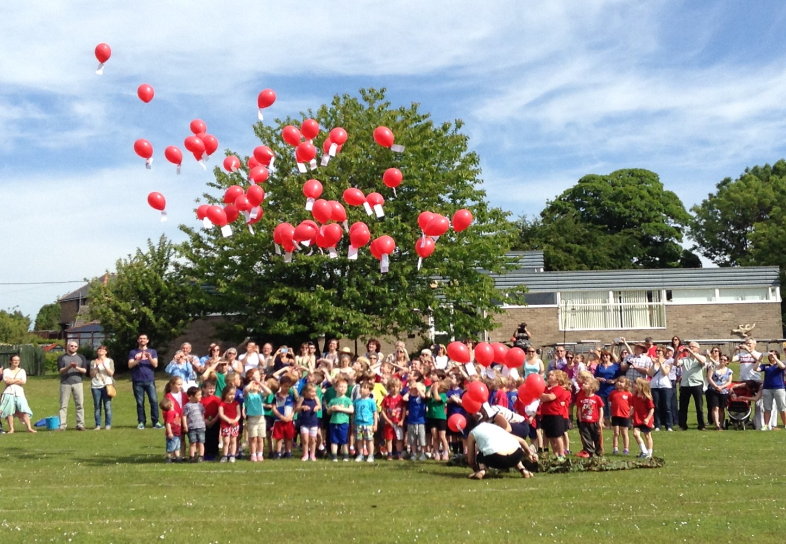
Felton C of E First School Curriculum Statement 2015-6
Parent Evaluation Sheet:
Please circle to rate the following statements from 1 to 5,

- = strongly disagree 5 = strongly agree

The meeting has increased my understanding of how the requirements of the National Curriculum

1 2 3 4 5

The meeting has increased my understanding of how the school curriculum is designed

1 2 3 4 5

The meeting has helped me understand how the school will be assessing children within the New National Curriculum

1 2 3 4 5

The meeting has helped me understand the new language and terminology used in relation to the assessment of pupils

1 2 3 4 5

Please circle your child’s year group: Y1 Y2 Y3 Y4

Any further comments you wish to make in support of our evaluation would be gratefully received - Thank you!

