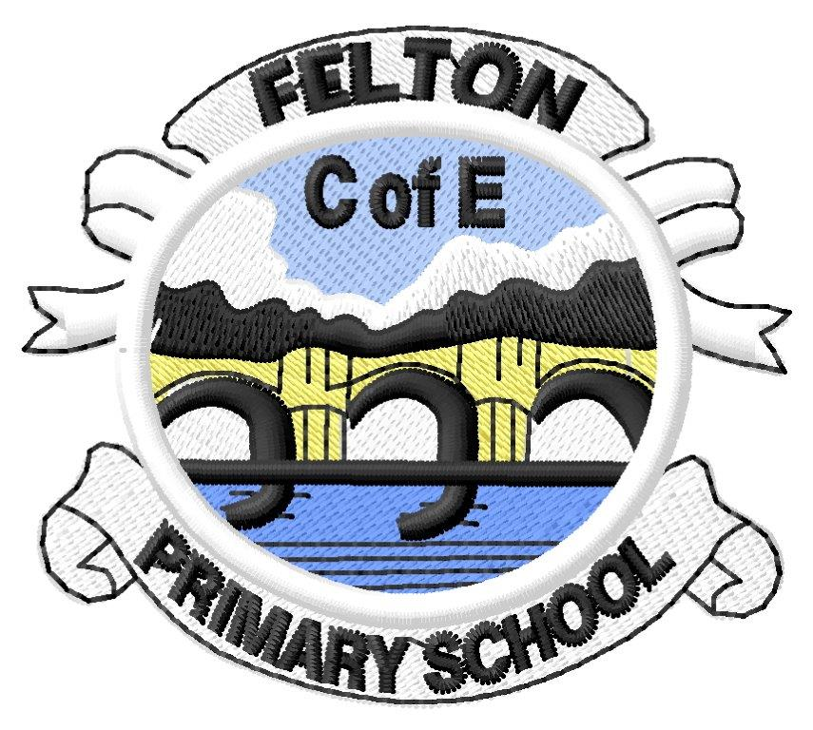MINI ADVENTURE CONTEXT PLAN
PIONEERS 2021-2022 AUTUMN TERM - DIVE IN!

Key Texts | Key knowledge and understanding | Key Inspirational Figure | Key Artistic Inspiration | Key Sustainable Development Goal
Treasure Island - Robert Louis Stephenson  ‘Giant’s Necklace’ short story from Hereabout Hill - Michael Morpurgo | Ocean currents and ocean layers  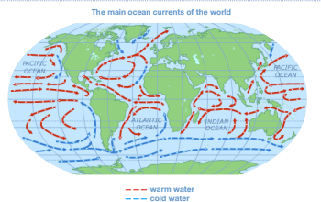  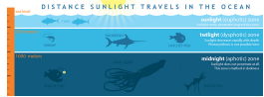 | Great explorers and oceanic journeys  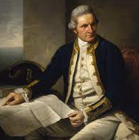  James Cook | Scientific marine drawings  Ernst Haeckel  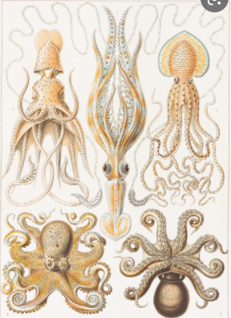 | Life below water  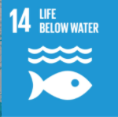

Hearts, Hands, Heads - Loving, Learning, Living
Loving - Hearts | Learning - Heads | Living - Hands
Gain a deeper appreciation for and understanding of the world’s oceans.  Empathise with those who chose to undertake long and difficult oceanic journeys.  To experience wonder and awe at the variety and scale of marine life - and to gain an understanding of the scope of which we do not yet know or have discovered! | To know the oceans of the world and the causes and effects of ocean currents.  To know the layers of the ocean and how the animals that live within each layer are adapted to survive there.  To know some key ocean explorers - the routes they took and their motivations to explore  To know observational drawing and printing techniques to create botanical, scientific drawings | Research oceans, currents, ocean layers and the marine life that lives there.  Organise findings and present findings to my peers.  Refine artistic techniques to represent marine life with scientific accuracy.  Represent the journeys taken by oceanic explorers using maps, timelines and accounts.

Opportunities for personal development
Spiritual | Moral | Social | Cultural
Learning to recognise a sense of awe, wonder and appreciation of the creation of the world around us. Reverence in the creation of oceans and the wonder of all we have yet to discover. Recognising that learning is a journey that we are all on, thinking about how we journey together, comparing our own journeys with those of key spiritual characters | To begin to consider the role they may play in the preservation of ocean life.  To consider the motivations for ocean explorers - were the intentions and outcomes for their expeditions were always positive, including for those whose countries they visited. | To gain an understanding of the interdependence society has upon the ocean and our responsibilities we have towards it. | To understand the reasons why historical explorers embarked upon difficult and long journeys - what modern day equivalents are there?  To know about the Bible and it’s cultural importance.

Time to Shine opportunities
Pretend you are embarking on an ocean expedition. What route would you take? Why? Justify the purpose of your adventure and your chosen route.
What creatures might you meet?

Writing |  |  | Reading |  |  | Maths
Write with purpose. Use imaginative descriptions. Organise paragraphs. |  |  | Understand texts |  |  | To know and use numbers. Addition.
What do I know already? | Can I structure a cohesive non-chronological report? Do my paragraphs make sense and form longer, cohesive pieces of writing? What techniques do I use to create imaginative descriptive writing? |  | What do I know already? | How do I |  | What do I know already? | What is meant by the term ‘place value’? How does the position of the digit in a number affect it’s value?
Big questions: | Can I use the main features of a non-chronological report in my own writing?  Can I take notes, develop and research ideas for my non-chronological reports?  Can I plan, draft, write, edit and improve my writing?  Can I use organisational devices such as headings and subheadings?  Can I use the techniques used by Michael Morpurgo in Giant’s Necklace to create characters, settings and plots in my own narratives?  Can I create vivid images by using alliteration, similes, metaphors and personification?  Can I interweave descriptions of characters, settings and atmosphere with dialogue?  Do I use correct tenses throughout a piece of writing?  Do I write paragraphs that give the reader a sense of clarity?  Can I sequence paragraphs in non-chronological reports and my narrative writing?  Can I write paragraphs that make sense if read alone?  Am I able to write cohesively at length?  Can I write sentences that include relative pronouns to add relevant detail?  Do I write fluently and legibly with a personal style? |  | Big Questions: | Can I read age-appropriate books, such as Treasure Island as a shared class novel, with confidence and fluency? Can I check that the book makes sense, discussing understanding and exploring the meaning of words in context, especially the archaic language of Treasure Island? Can I predict what might happen from details stated and implied?  Can I draw inferences such as inferring characters’ feelings in Giant’s Necklace and Treasure Island, thoughts and motives from their actions, and justifying inferences with evidence?  Can I discuss words and phrases that capture the imagination?  Can I summarise the main ideas drawn from more than one paragraph, identifying key details that support the main ideas?  Can I discuss and evaluate how Robert Louis Stephenson and Michael Morpurgo use language, including figurative language, considering the impact on the reader?  Do I ask questions to improve my understanding of a text?  Do I participate in discussions about books, taking turns and listening and responding to what others say?  Can I retrieve and record information from non-fiction, using titles, headings, sub-headings and indexes? |  | Big Questions: | Can I count in multiples of 2 to 9, 25, 50, 100 and 1000?  Can I read numbers up to 10 000 000.  Can I use negative numbers in context and calculate intervals across zero?  Can I identify, represent and estimate numbers using different representations?  Can I write numbers up to 10 000 000? Order and compare numbers up to 10 000 000?  Can I round any whole number to a required degree of accuracy?  Can I determine the value of each digit in any number?  Can I read Roman numerals to 1000 (M) and recognise years written in Roman numerals?  Can I add and subtract whole numbers with more than 4 digits, including using formal written methods. (columnar addition and subtraction)?  Can I add and subtract numbers mentally with increasingly large numbers?  Can I use rounding to check answers to calculations and determine, in the context of a problem, levels of accuracy?  Can I add and subtract negative integers (whole numbers). Add and subtract amounts of money to give change. (£ and p)
Contexts for learning | Talk for writing techniques to learn an effective non-chronological report structure - application to non-chronological reports about marine animals, marine biomes and ocean explorers (linking to writing biographies)  Ocean story narrative writing using themes and story structures of Giant’s Necklace (building effective tension) |  | Contexts for learning | Treasure Island shared as class novel.  Guided reading based upon Treasure Island, with focus upon understanding unknown/archaic language, drawing inferences about a character’s motives.  Giants Necklace short story used to support narrative writing in English - analysis of text for author’s techniques to build tension |  | Contexts for learning | Varied fluency, problem solving and exploration of place value representations, Roman Numerals and addition/subtraction and problem solving.
Key Vocabulary | Non-chronological, note, research, subheading, character, setting, plot, alliteration, simile, metaphor, personification, tense -present, past, future (perfect), cohesive, paragraph, relative clause, relative noun |  | Key Vocabulary | Archaic language - to be gathered during class novel time and displayed on vocabulary wall  Infer, motive, feeling, justification, figurative language - alliteration, metaphor, simile, personification |  | Key Vocabulary | Multiples, place value, digit, integer, representations, compare, order, round, estimate, decompose
Geography |  |  | History |  |  | PSHE
To investigate places. To investigate patterns. |  |  | To investigate and interpret the past. |  |  | Mental Health
What do I know already? | Do I know the names of the oceans? What can I explain is meant by an ocean current? What are the different layers of the ocean like? What lives within each one? |  | What do I know already? | Can I name any explorers or famous expeditions? |  | What do I know already? | What is meant by ‘mental health’? How is this different from physical health? What may link the two?
Big Questions: | Can I ask and answer geographical questions about the physical characteristics of a marine biome, including the characteristics of the different layers of the ocean?  Can I explain my own views about marine locations, giving reasons and justifications?  Can I use maps, atlases, globes and digital/computer mapping to locate oceans, countries and describe features?  Can I use a range of geographical resources to give detailed descriptions and opinions of the characteristic features of a marine biome? Can I name and locate some of the countries and oceans of the world and their identifying human and physical characteristics, key topographical features and land-use patterns; and understand how some of these aspects have changed over time. Can I describe and give key aspects of: physical geography, including: climate zones and biomes?  Can I describe how locations around the world are changing and explain some of the reasons for change? |  | Big Questions: | Can I use sources of evidence to deduce information about the historical oceanic expeditions? - Seek out and analyse a wide range of evidence in order to justify claims about the past.  Can I describe the social, ethnic, cultural or religious diversity of past society using the motivations and aspirations of marine explorers as context?  Can I understand the concept of change over time, representing this, along with evidence, on a timeline?  Identify periods of rapid change in history (relating this to the rapid period of discovery and world view changing discoveries by explorers such as James Cook) and contrast them with times of relatively little change and exploration.  Do I use dates and terms accurately in describing events?  Do I use appropriate historical vocabulary to communicate, including: dates, time period, era, change, chronology? |  | Big Questions: | Do I recognise that mental health is just as important as physical health and that both need looking after?  Do I recognise that anyone can be affected by mental ill-health and that difficulties can be resolved with help and support?  Can I recognise, respect and express my individuality and personal qualities?  Can I discuss my personal identity and what contributes to it, including race, sex, gender, family, faith, culture, hobbies, likes/dislikes?  Do I know ways to boost my mood and improve emotional wellbeing?  Can I discuss the link between participating in interests, hobbies and community groups and mental wellbeing?
Contexts for learning | Know the world’s oceans and their diversity.  Understand ocean currents and the layers of the ocean - including what marine life lives within each and why (see Science) |  | Contexts for learning | Research and study the life and expeditions of James Cook - charting journeys using maps and understanding chronological events using timelines. Learn about the motivations for James Cook and the impacts his expeditions have had. |  | Contexts for learning | Class discussion and personal reflection about individuality and qualities. Identification of their personal preferences, identity and self-awareness - and the links to hobbies/interests and mental wellbeing - ‘good to be me’
Key Vocabulary | Ocean, sea, marine, biome, current, continuous, gyres, hemisphere, Atlantic, Pacific, Arctic, Antarctic, Indian, sunlight (euphotic) zone, twilight (dysphotic) zone, midnight (aphotic) zone, phytoplankton, photosynthesis, saline |  | Key Vocabulary | Expedition, civilisations, trade, resources, circumnavigate |  | Key Vocabulary | Mental health, physical health, individuality, personal qualities, emotional wellbeing

French |  |  | PE |  |  | Music
Read fluently, speak confidently |  |  | Net and wall games. Batting and fielding (cricket). |  |  | To perform.
What do I know already? | Can I use basic French to introduce myself? Do I know key vocabulary for home and school? |  | What do I know already? | What skills, techniques and game play can I recall from previous year’s cricket sessions? Can I apply, refine and improve these skills further? |  | What do I know already? | What playing position, notes or chords can I remember when playing a Ukelele?
Big Questions: | Am I able to follow spoken French when I know the context? Can I read sentences using vocabulary I know? Am I able to speak in the simple future tense? |  | Big Questions: | Can I choose and combine techniques in game situations (running, throwing, catching, passing, jumping and kicking, etc.)?  Can I work alone, or with team mates in order to gain points or possession?  Can I strike a bowled ball with accuracy?  Can I field, defend and attack tactically by anticipating the direction of play?  Can I follow the rules of the game and play fairly? Can I choose the most appropriate tactics for a game? Can I uphold the spirit of fair play and respect in all competitive situations?  Can I lead others when called upon and act as a good role model within a team? |  | Big Questions: | Can I sing from memory with accurate pitch?  Can I sing or play from memory with confidence and in tune and with expression?  Can I perform solos or as part of an ensemble?  Can I maintain a simple part within a group?  Can I hold a part within a round?  Can I sustain a drone or a melodic ostinato to accompany singing?  Can I perform with controlled breathing (voice) and skillful playing (instrument)?  Can I use the terms: duration, timbre, pitch, beat, tempo, texture and use of silence to describe music?
Contexts for learning | Talk about the future - what would you like to be when you grow up? Describing emotions in French. Using the future tense to retell a traditional tale. Presenting information about myself to a small audience. |  | Contexts for learning | Weekly cricket coaching sessions. Net and wall games weekly skills sessions. Weekly yoga session. Weekly Felton Mile. |  | Contexts for learning | Weekly Ukelele lesson. Ongoing musical appreciation opportunities linked to the theme of Oceans.
Key Vocabulary | Vocabulary in french linked to the context of learning |  | Key Vocabulary | Field, bat, tactically, anticipation, accuracy, wicket |  | Key Vocabulary | duration, timbre, pitch, beat, tempo, texture, expression, ensemble, round, ostinato

DT |  |  | Computing |  |  | RE
Construction. Mechanics |  |  | To connect. To communicate. |  |  | Big Story of the Bible
What do I know already? | Can convert circular motion into linear motion? |  | What do I know already? | Do I know how to organise my online learning so it is accessible for myself and my teachers?  What ways can I present my research and learning using ICT? |  | What do I know already? | Can I tell the ‘Big Story’ of the Bible?
Big Questions: | Can I use develop a range of practical skills to create products (such as cutting, drilling and screwing, nailing, gluing, filing and sanding).  Can I convert rotary motion to linear using cams?  Do I make products through stages of prototypes, making continual refinements? Do I continually evaluate the product design?  Do I use my art skills to ensure products have a high quality finish?  Can I evaluate the design of products so as to suggest improvements to the user experience? |  | Big Questions: | Can I collaborate with others online on sites (or platforms such as google Classroom) approved and moderated by teachers?  Can I give examples of the risks posed by online communications?  Do I understand that comments made online that are hurtful or offensive are the same as bullying?  Do I understand how online services, such as Classroom work?  Can I choose the most suitable applications and devices for the purposes of communication?  Can I use many of the advanced features in order to create high quality, professional or efficient communications?  Can I select appropriate applications to devise, construct and manipulate data and present it in an effective and professional manner? |  | Big Questions: | What is the Bible?  Why is the Bible important to Christians?  What is the ‘Big Story’ of the Bible?
Contexts for learning: | Create a wave model using CAM motion (Y6 using multiple CAMs, synchronising movement in a wave motion) |  | Contexts for learning: | Re-familiarise ourselves with Google Classroom as a platform for online learning. Learn to submit assignments which include a variety of media. Research effectively and present findings. Organise work using appropriate file structures and names. |  | Contexts for learning | Learn some key facts about the Bible, place stories that we already know into the ‘Big Story’ of the Bible. Order a timeline of events in the Bible and tell the ‘Big Story’. Learn some key theological concepts that come from the ‘Big Story’ and create a representation of the Big Story of the Bible to help people understand it. Reflect on why the Bible is important to Christians and evaluate whether the Bible is still important in twenty first century Britain.
Key Vocabulary | CAM, linear, rotary, evaluate, eccentric circle, CAM follower, pivot |  | Key Vocabulary | Collaborate, communication, file name, application, organise, risks |  | Key Vocabulary | Bible, biblical, Old Testament, New Testament, Hebrew Scriptures, Greek, chapter, verse, theological, Creation, Fall, People of God, Incarnation, Gospel, Salvation, Kingdom of God.

Art
To develop ideas. To draw. To print.
What do I know already? | Can I make an accurate observational drawing of a marine animal, applying my drawing skills from previous years? What printing techniques do I know already?
Big Questions: | Can I develop ideas from starting points throughout the curriculum? Can I collect information, sketches and resources and present ideas imaginatively in a sketchbook? Adapt and refine ideas as they progress?  Can I use different hardnesses of pencils to show line, tone and texture? Can I use a variety of techniques to add interesting effects (e.g. reflections, shadows, direction of sunlight).  Can I use a choice of techniques to depict movement, perspective, shadows and reflection?  When printing: Can I build up layers of colours? Create an accurate pattern, showing fine detail? Use a range of visual elements to reflect the purpose of the work? Make precise repeating patterns?  Can I replicate some of the techniques used by notable artists, artisans and designers?
Contexts for learning | Make accurate observational, scientific drawings of marine animals, using the work of Ernst Haeckel as inspiration. Transfer these accurate drawing skills to creating accurate printed representations of marine animals.
Key Vocabulary | Line, tone, texture, printing techniques, layering, relief, inverted, block

