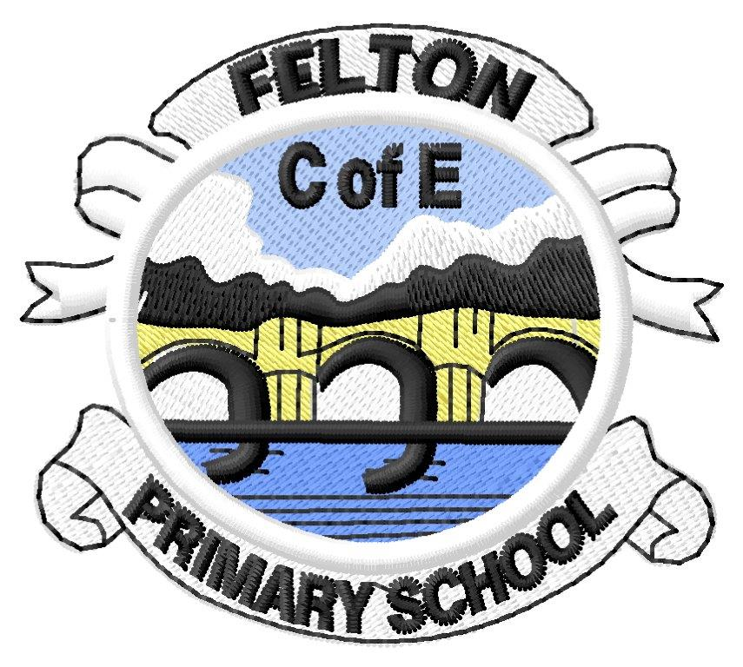Pioneers’ Autumn Newsletter 2021-2022

I am so pleased to welcome the Pioneers back this week. They have begun to settle in so well and should be very proud of themselves for their mature and calm start to the year. I am excited to be their teacher and, in the case of the Year 6s, feel so privileged to guide them through their final year as primary pupils.

I am excited to begin this new school year with a Mini Adventure called ‘Dive In’. Please see the Mini Adventure sheet for this topic for all details, but as a brief overview we will be:
- Diving down to discover the different layers of the ocean, discovering what marine life lives in each and how they are adapted to survive in such differing and diverse conditions
- Discovering all about ocean currents: why they occur and the impact they have upon the planet as a whole.
- Finding out about key explorers, such as James Cook, to discover where they voyaged, their motivations for undertaking such dangerous expeditions and the impact their explorations had.
- Reading Treasure Island as our class novel - exploring the text in guided reading and charting the journey upon our world map.
- Being inspired by the combined scientific and artistic skills of artists such as Ernst Haeckel and creating our own drawings and prints of marine animals.
- Being awed and inspired by the scale, scope and wonder of our oceans!

Weekly routine
Pioneers will be taught by myself (Mrs Gamston) on Mondays, Tuesdays, Wednesdays and Thursdays, which are my days in school this year. On Fridays, Pioneers will have: Ukuleles (with Flora), RE (with Miss Weir), CLICs/BMBTs (with Mrs Dixon) and Forest Schools (with Ms Leithead, Miss Weir, Mr Shaw and Mrs Dixon, alongside the Voyagers).

Snacks and water bottles
Each day, the children will need a healthy mid-morning snack (a piece of fruit is ideal), if they wish. Now we are able to have a KS2 bubble and therefore dinnertime at 12.15, snacks no longer need to be as substantial as was required last year! Please can children bring a water bottle to school to ensure they stay hydrated throughout the day.

Reading and Spelling
Over the coming week, all children will have the opportunity to choose a reading book to bring home. Mrs Dixon and I will be listening to all children read over the coming week and we will ensure their reading book is of a suitable level and promote reading for pleasure. Once the children have finished their books, they will need to place them in the returned books box situated in the classroom.

The children will take part in a guided reading session once per week. They will also have a weekly opportunity to respond to their current home reading book, for example by writing a book review or completing a character profile. This will allow us to track their reading choices and ensure they are engaging well with their reading books. As they are in Y5&6, your child may not necessarily be reading aloud to you, but please spend some time talking to your child about their reading book and encourage them to spend some time each day reading.

We will resume our daily Read, Write, Inc spelling sessions, including a weekly spelling check, when we have checked the children’s current spelling knowledge. These checks will take place over the next few weeks and we will be in touch prior to spelling lists being sent home for the first time.

Homework
After the success and high engagement with our online homework format last year, I intend to continue to use the Google Classroom to set and respond to homework tasks. We will start homework within the next couple of weeks.

PE and The Felton Mile
Each day, the children will take part in a PE or active session:
- Monday am - yoga
- Tuesday am - PE skills session
- Wednesday am - Felton Mile
- Thursday pm - Cricket coaching (Autumn term)

On Mondays, Tuesdays and Wednesdays, the children will be active at the start of the school day, please can they arrive on these days in their PE kits. They will need to bring their school uniform with them in order to get changed after the morning session. PE kits will go home each night as required for the children to return wearing it the next day.

On Thursdays, the cricket session is in the PM. Please can children come to school in their uniforms and they will get changed into PE kits after lunch.

Friday Forest Skills
Please can we ask that your child comes to school on Friday with adequate clothing for Outdoor Learning. The children can bring:
- Warm trousers, in line with school uniform colours (ones that can get dirty)
- Warm socks/ welly socks
- A change of footwear (walking boots or wellies)
- Layered tops – t-shirts/long sleeved tops/jumpers (we do ask children still wear their school jumper or cardigan as their top layer)
- The school will provide waterproof coats and trousers

The children will have time to dress appropriately for the weather before they go outside, please can they arrive at school wearing their uniform tops and jumpers. Warm trousers in school colours can be worn, however please note jeans and leggings are not suitable for Forest Schools activities.

Here’s to a happy, successful and positive year for the Pioneers! If there is anything you should wish to discuss, please do not hesitate to get in touch.

Nikki Gamston

